Critical Analysis

This report will compare two Napier Univeristy website course searches. As the two sites are for Napier Univeristy, one site will be referred to as napier.ac.uk, which is the current course search used on the Universities website, and the other will be referred to as the Napier search.

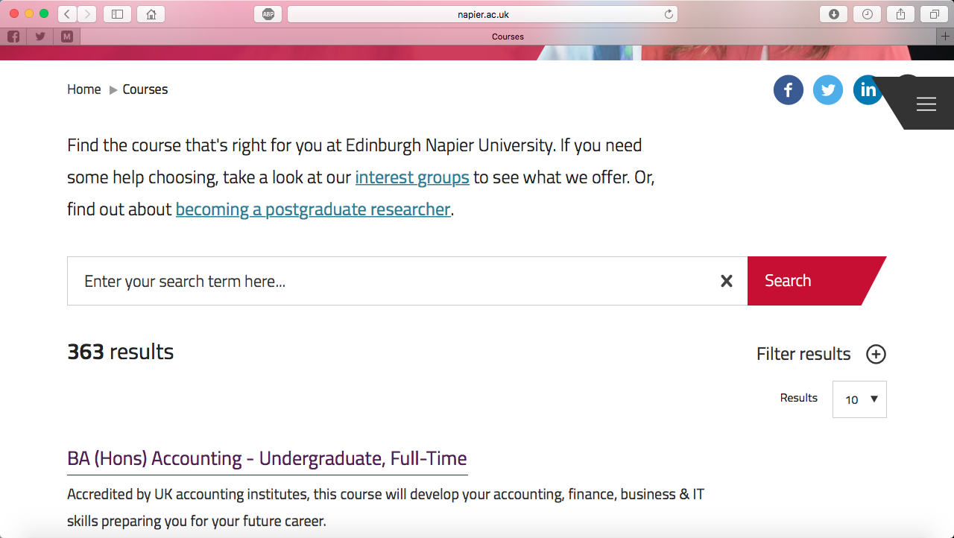Napier.ac.uk use their initial search page to display the search results, although to see the results, the user has to scroll down the page as the search bar is just above where the page cuts off. The information visible initialy, is very limited and keeps the top part of the page free from any distractions. Napier.ac.uk show only five pieces of information in their search results; the award, the course, the level, the study mode, and a summary of what the course is. Napier.ac.uk’s search results have a couple of good features. The user can filter the results and decide how many results can be seen at once.

On napier.ac.uk’s course information pages, they give quite a lot of information. Although a lot of information is given, they use a tab menu system so that the page is not too overloaded with information. Not all course information pages provide details of the modules that are taken on the course but often include details of some of the subjects taken and provide a link to the website’s module section. Links are also given to a page with courses within the same school.

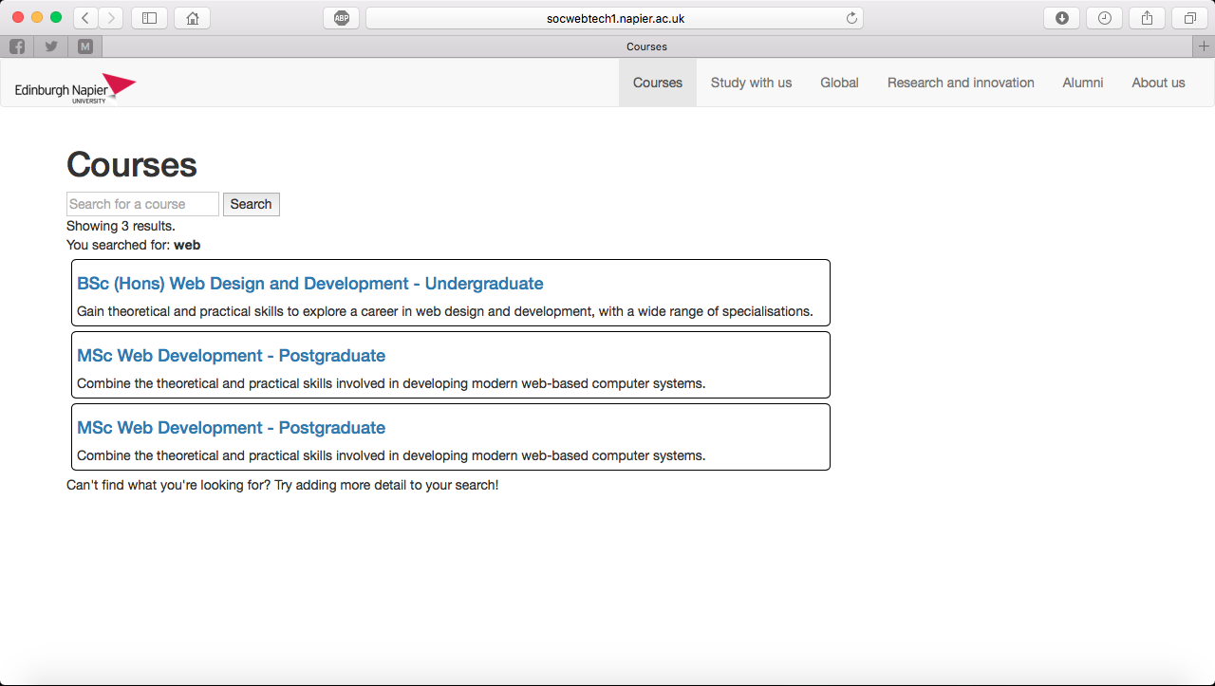On the first page of the Napier site search, there is only the site navigation, branding, a page heading and the search bar. This means that the page is completley free from any distraction. The results page is almost identical with the only difference being the results below the search bar. The only information given in the results page is the award, course, level and a summary of the course. Only ten results are displayed for each search and users are told to add more information to their search if they can’t find what they are looking for.

All the required information is displayed on the course information page with only small amounts of information being displayed at a time, through the use of pills (buttons). Again module information is only provided on some pages but there is no link to a modules section. There is also no information about related courses.

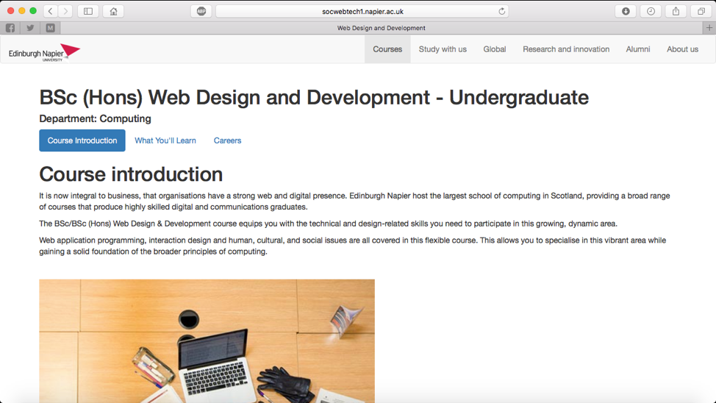

Overall, both sites have clean designs and provide potential students with the information they need about courses in a way that is not overwhelming for them.